# **Comparison of waste disposal of CO2 b/w different countries**

The data was taken from HP Z-Unlocked Competition on 18th August 2022. The **purpose** of collecting this data was to compare waste disposal in different countries concerning **CO2** in **kilotons** over **30** different years from **1990 to 2020**. We selected data from the competition and it consists of columns (Domain Code, Domain, Area Code (ISO3), Area, Element Code, Element, Item Code, Item, Year Code, Year, Unit, Value, Flag, Flag Description) with unique values as (Domain Code 1, Domain 1, Area Code (ISO3) 217, Area 217, Element Code 1, Element 1, Item Code 1, Item 1, Year Code 30, Year 30, Unit 1, Value 3411, Flag 2, Flag Description 2) with data analysis.

1. Domain Code having GW 🡪 Global Warming value only
2. Domain having Waste disposal value only
3. Area Code (ISO3) codes of different countries
4. Area representing different countries
5. Element Code representing code of CO2 as seven thousand two hundred seventy-three (7273)
6. Element having only one value as Emissions (CO2)
7. Item Code representing items codes that are only one
8. Item representing Incineration 🡪 means the destruction of something in progress
9. Year Code representing different years codes
10. Year representing different years
11. Unit representing only one value kilotons
12. Value representing the number of CO2 emissions in unit kilotons
13. Flag representing flag short name that is only two
14. Flag Description represents two types of description over the flag

We analyzed the data and dropped columns having only 1 or 2 rows because these columns were not of effective use while wrangling over the data even with being label encoded these were not that effective, so we just dropped those columns, and the only effective columns were having values more than 1 or 2 and after removing outliers from those with quartile range technique, we got the cleanest form of our data

## **Interpretations:**

**Highest Emission Countries:**

China 🡪 2020, China, mainland 🡪 2020, Japan 🡪 2013

1. **Lowest Emission (almost 0k):**

Vanuatu, Uganda, Thailand, South Africa, Senegal, Romania, Papua New Guinea, Nicaragua, Montenegro, Malawi, Lao People’s Democratic Republic, Kazakhstan, Israel, Hungary, Guam, Fiji, Denmark, Burkina Faso, Belgium Luxembourg, Azerbaijan,

1. **Highest Emission (8k – 12k):**

**Orange** 🡪Albania, Armenia, Brazil, Chile, China, Macao SAR, Czechia, El Salvador, Japan, Lithuania, Mexico, Nepal, Oman, Samoa, Slovakia, Sweden, Turkey, United States Virgin Islands, Zimbabwe, China

**Purple** 🡪 Algeria, Austria, Belgium, Bhutan, Bulgaria, Canada, Democratic Republic of Congo, Faroe Islands, Honduras, Isle of Man, Libya, Mauritania, Mongolia, New Zealand, Panama, Republic of Moldova, Saudi Arabia, Somalia, Tajikistan, Tuvalu, Uzbekistan

**Pink** 🡪 American Samoa, Bahamas, Bolivia, Colombia, Djibouti, Eritrea, Finland, Gibraltar, Guatemala, Iceland, Kenya, Latvia, Liechtenstein, Malaysia, Morocco, Niger, Paraguay, Russian Federation, Serbia, South Sudan, Timor-Leste, Ukraine, Venezuela

1. **Just for knowledge:**

Pakistan (Green) 🡪 between 100 and 1300

India (silver)🡪 almost 2000

**Years Of Emission:**

Emission is increasing day by day, but the highest emission was recorded in 2020 by China

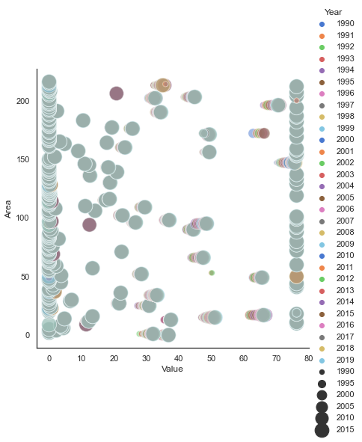The above interpretations were taken from these graphs given below: 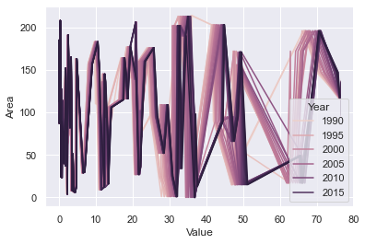

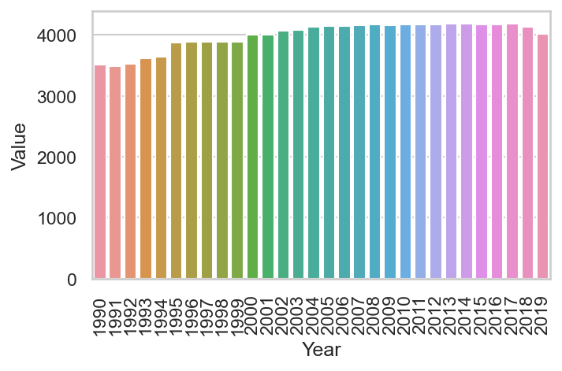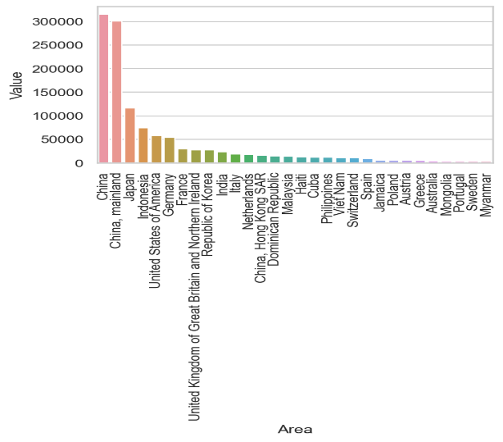

## **Results:**

The emission of CO2 was compared using [Python](https://www.python.org/) using [VS code](https://code.visualstudio.com/) IDE and performed data analysis build-in libraries of Python. It has been increasing, the highest emission is recorded as per our data. Countries having different emission records are mentioned above.

## **Conclusion or Recommendation:**

The world is releasing the bulk of the amount of gas in the atmosphere, so we need to take care of our world and because it has already caused global warming as well that is the current issue of the world.

We have records of different courtiers and according to that, we may at least give them a warning or so to stop huge bulk of emission, do it but just some restrictions or we going to lose this world

You can take recent years’ data and try to use different samples and different techniques. Change your perception about the comparison methodology

Sahil Ali

Useless kid

Just Vice Chair ACM/W

[Sahiljatoi744@gmail.com](mailto:Sahiljatoi744@gmail.com)